**CHURN PREDICTION :**

**Turi Use case :** <https://github.com/turi-code/sample-churn-predictor>

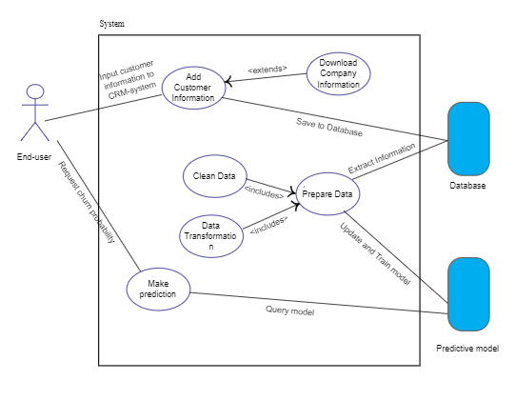

**Types of Churn :**

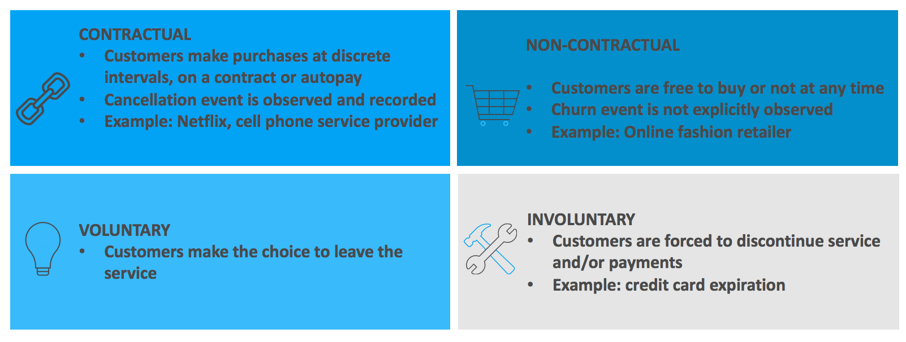

**USE CASES :**

* Measuring feature impacts on the likelihood of churn in order to understand why customers choose to leave, which can inform long-term retention initiatives
* Creating churn risk scores that can indicate who is likely to leave, and using that information to drive retention campaigns
* Predicting the probability of churn and using it to flag customers for upcoming email campaigns
* Integrating outputs with internal apps, such as a customer call center, to provide relevant real-time churn risk information
* [Discounting strategically](https://www.datascience.com/resources/white-papers/five-steps-to-data-driven-discounting-guide) with promotion campaigns to customers with a high cancellation risk.

**BUSINESS USE CASE :**

Companies need an effective strategy for managing customer churn. Customer churn includes customers stopping the use of a service, switching to a competitor service, switching to a lower-tier experience in the service or reducing engagement with the service.

In this use case, we look at data from French telecom company Orange to identify customers who are likely to churn in the near term in order to improve the service and create custom outreach campaigns that help retain customers.

Telecom companies face a competitive market. Many carriers lose revenue from postpaid customers due to churn. Hence the ability to accurately identify customer churn can be a huge competitive advantage.

Some of the factors contributing to telecom customer churn include:

* Perceived frequent service disruptions
* Poor customer service experiences in online/retail stores
* Offers from other competing carriers (better family plan, data plan, etc.).

In this solution, we will use a concrete example of building a predictive customer churn model for telecom companies.